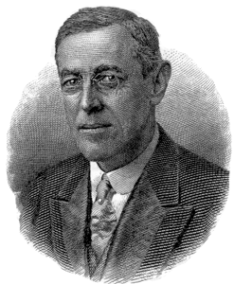
http://www.bartleby.com/124/wilson.gif
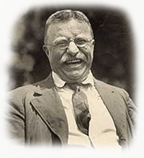
http://www.allesamerika.com/images/teddy_roosevelt.gif

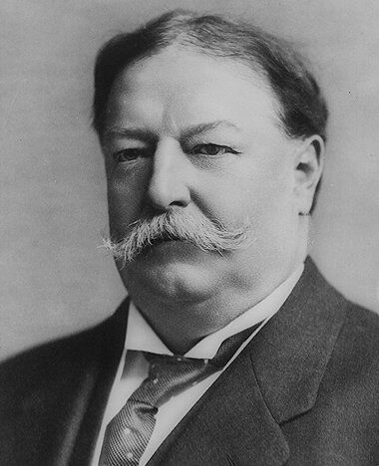
http://www.historyplace.com/specials/calendar/docs-pix
/wh-taft.jpg
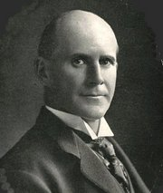
http://upload.wikimedia.org/wikipedia/en/thumb/6/6c/Eugene
_v_debs_1912.jpg/180px-Eugene_v_debs_1912.jpg

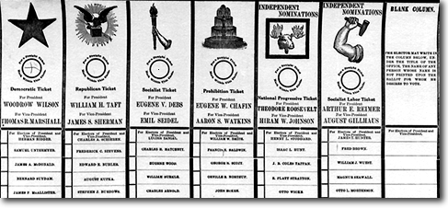
www.hfmgv.org/exhibits/ pic/1996/96.nov.html

From the turn-of-the-century until World War I, America will experience three very different Presidents in three consecutive terms. In 1912, the three run against each other in a rare three-horse race. Three “third” party candidates were also on the ballot. You and your partners will analyze one candidate, prepare a campaign; including a Party Platform, a Campaign Speech, a Poster, a Pamphlet and campaign buttons. You will present your candidate and his campaign to the class on___________________________.

Working with your partners you will use the following to develop the campaign for your candidate:

- Why are you running? Formulate the Platform for your political party and your candidate. Use persuasive rhetoric AND actual facts when writing the party platform.

- What are your top accomplishments? Name and explain them. Then rate yourself as a Progressive, from 1-10, 1 being not at all “Progressive.” Use persuasive rhetoric and convincing arguments in the campaign speech – Remember: you must win over the voters – convince them of why you are the best candidate for the Presidency in 1912.

- Who are your constituents? What groups of society will support you? What are the characteristics of those groups? The Party Platform, the campaign speech and the Political Propaganda (poster, pamphlet, buttons) must appeal to your constituents – convince them you are the best candidate for the Presidency in 1912. Use this in all of these media.

- How could you discredit your competition? What political weaknesses do your opponents have? What did they fail to accomplish? Who did they fail to serve? Include this in the campaign speech – be careful with your wording so that this doesn’t cause you and your party to lose votes.

- Where do your greatest weaknesses lie? What have you not done well? Put a “spin” on this in your campaign speech – turn a negative into a positive.

- Areas of Concentration: Foreign Policy, basically imperialism, also Domestic Policy including, but not limited to, Corporations, Unions, Environment, and women. Cover the military both foreign and domestic involvement.

Group Responsibilities:

Presidential Candidate – helps gather facts, writes and gives the Speech_____________________________

Party Chairman – gathers & uses facts gathered by all members to write and present the Party Platform
_____________________________________________

Campaign Managers – help gather facts, create campaign slogan, design and create poster, design and create pamphlet, design and create buttons. You make sure all propaganda is displayed in the room on campaign day. You also talk to constituents during the development of the campaigns in an effort to win votes for your candidate.

____________________________________________ & ____________________________________________

Keep this project in perspective!!! Yes, you are Honors students ~ but you do have a time limit ~ make effective use of the class time offered. Have fun, be creative, and learn about your candidate.

Party: ____________________________________________

Project Members:

1) ____________________________________________ email______________________________________
Phone_____________________________________
2) ____________________________________________ email______________________________________
Phone_____________________________________
3) ____________________________________________ email______________________________________
Phone_____________________________________
4) ____________________________________________ email______________________________________
Phone_____________________________________

